**Chapter 4 Understanding and Comparing Distributions**

One quantitative variable and one categorical variable

Comparing distributions – usually it is more interesting to compare groups

Histograms – Figure 4.2, p. 85

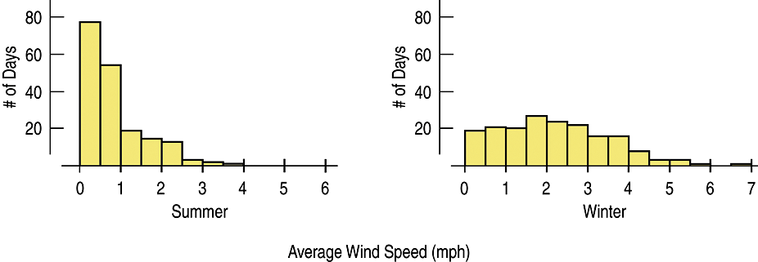

Stem-and-Leaf – For Example, p. 86

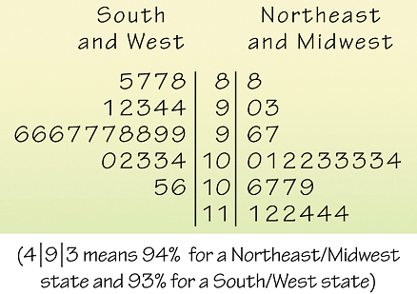

Boxplots – Figure 4.3, p. 87

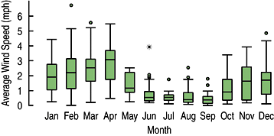

(*Skip Timeplots and Re-expressing data)